Assignment: A* Search Algorithm

Course: Artificial Intelligence

Topic: A* Search Algorithm

1. Introduction
A* (A-star) search algorithm is one of the most popular and efficient informed search algorithms used in Artificial Intelligence. It is a best-first search algorithm that finds the optimal path from a start node to a goal node by combining the actual cost and heuristic information.
The algorithm uses an evaluation function:
f(n) = g(n) + h(n)
Where:
- g(n) = actual cost from the start node to node n
- h(n) = heuristic estimate of the cost from node n to the goal
- f(n) = estimated total cost of the path through node n

2. Problem Description
- Start Node: Bhabanipur
- Goal Node: Mawna
The given graph consists of different locations connected by weighted edges representing path costs. Heuristic values are provided for each node to estimate the distance to the goal.
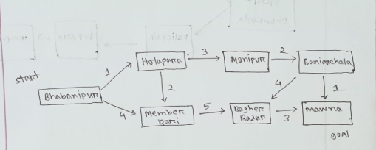

3. Heuristic Values
Node | Heuristic h(n)
Bhabanipur | 10
Hotapara | 8
Member Bari | 7
Monipur | 5
Baniarchala | 2
Bagher Bazar | 3
Mawna | 0

4. Step-by-Step Execution of A* Algorithm

Step 1: Start at Bhabanipur
- g = 0
- h = 10
- f = 0 + 10 = 10

Step 2: Expand Bhabanipur
Bhabanipur → Hotapara
- g = 1
- h = 8
- f = 1 + 8 = 9
Bhabanipur → Member Bari
- g = 4
- h = 7
- f = 4 + 7 = 11
➡ Node with lowest f-value: Hotapara

Step 3: Expand Hotapara
Bhabanipur → Hotapara → Monipur
- g = 1 + 3 = 4
- h = 5
- f = 4 + 5 = 9
Bhabanipur → Hotapara → Member Bari
- g = 1 + 2 = 3
- h = 7
- f = 3 + 7 = 10
➡ Node with lowest f-value: Monipur

Step 4: Expand Monipur
Bhabanipur → Hotapara → Monipur → Baniarchala
- g = 4 + 2 = 6
- h = 2
- f = 6 + 2 = 8
➡ Node with lowest f-value: Baniarchala

Step 5: Expand Baniarchala
Bhabanipur → Hotapara → Monipur → Baniarchala → Mawna
- g = 6 + 1 = 7
- h = 0
- f = 7 + 0 = 7
➡ Goal node reached.

5. Final Optimal Path
Bhabanipur → Hotapara → Monipur → Baniarchala → Mawna

6. Total Path Cost
Total Cost = 1 + 3 + 2 + 1 = 7

7. Conclusion
The A* search algorithm successfully finds the optimal path from Bhabanipur to Mawna by selecting nodes with the minimum evaluation function value. By combining actual path cost and heuristic estimates, A* ensures both efficiency and optimality. The shortest and least-cost path obtained has a total cost of 7.

